Nama : Elfaditiya Wardaya

Nim : 1800018064

Slot : Jum’at 16.30

Kegiatan Prak 1 PWD

Link Github :

Langkah-langkah Praktikum :

Source Code Counter.php

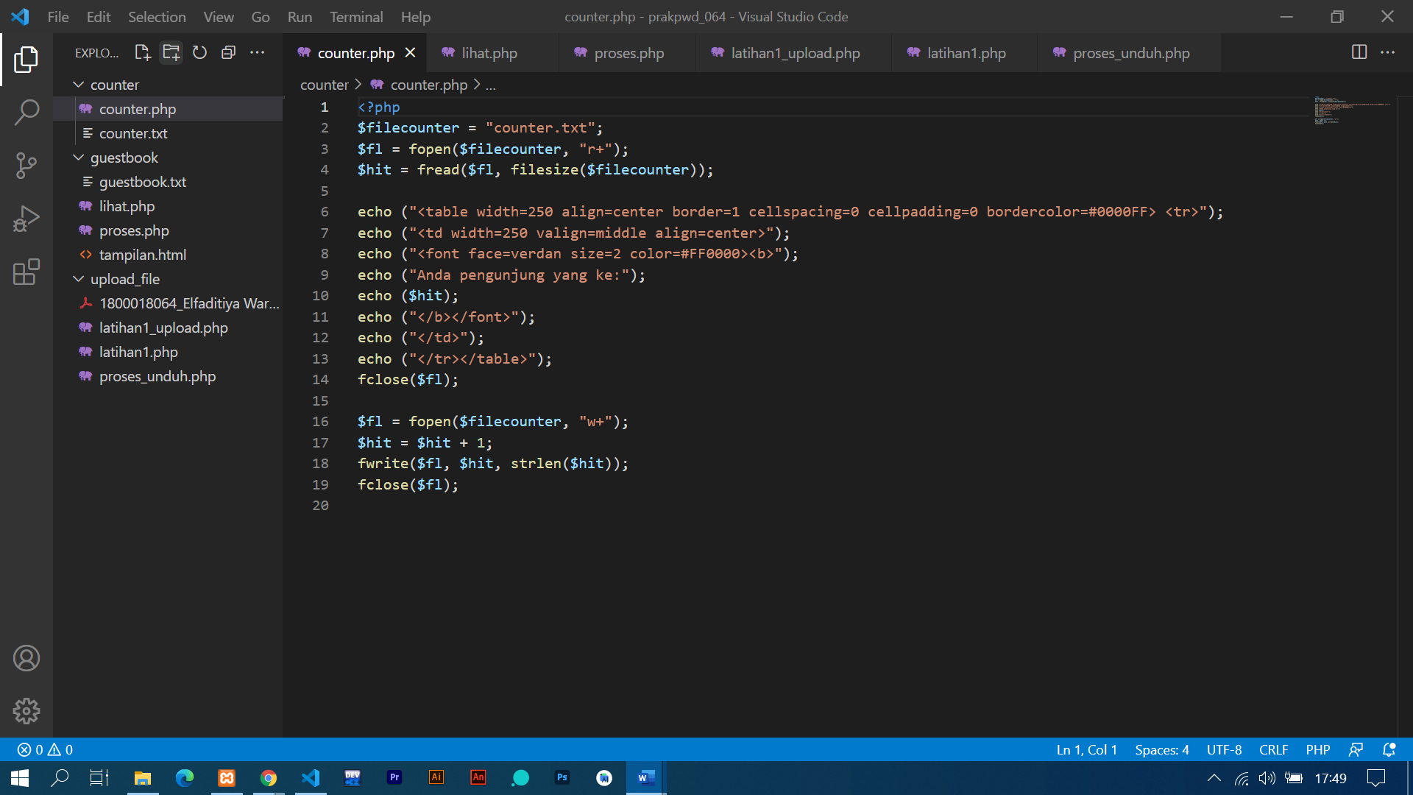

Tampilan Program

Source Code Guestbook lihat.php

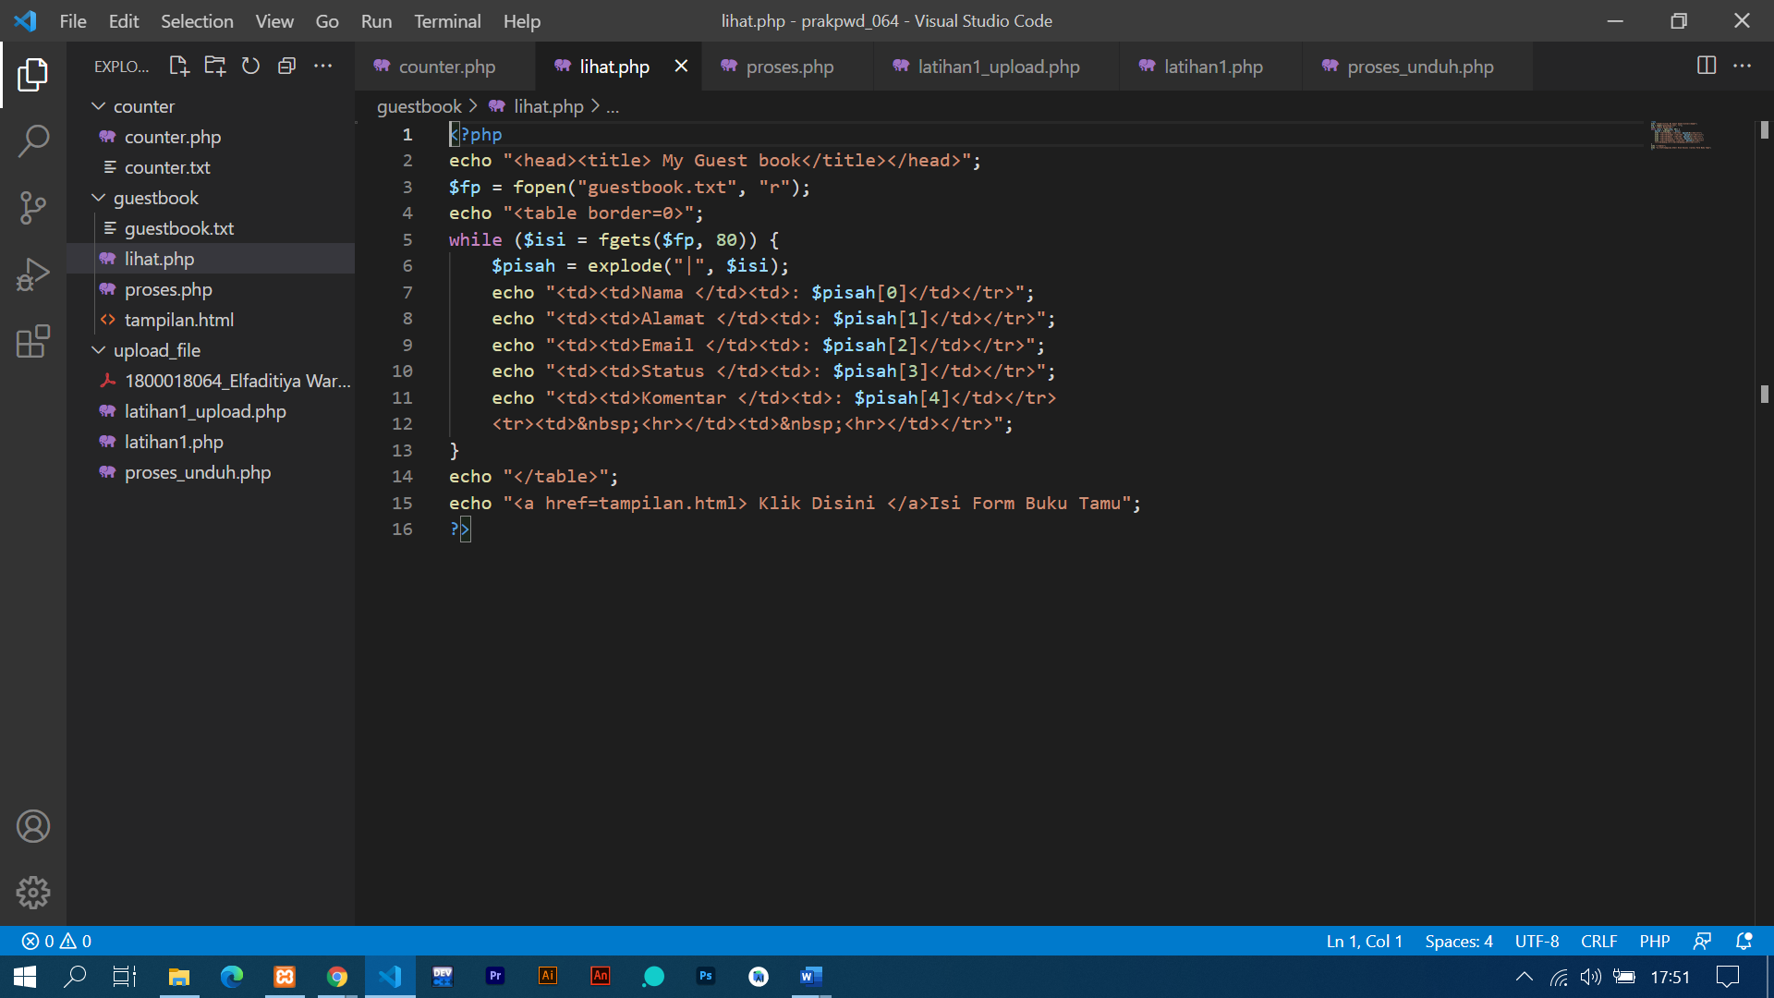

Tampilan Program

Source Code Guestbook tampilan.html

Tampilan Program

Source Code Guestbook proses.php

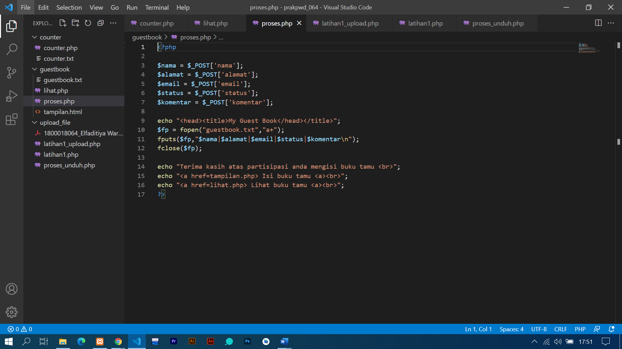

Tampilan Program

Source Code Upload latihan1.php

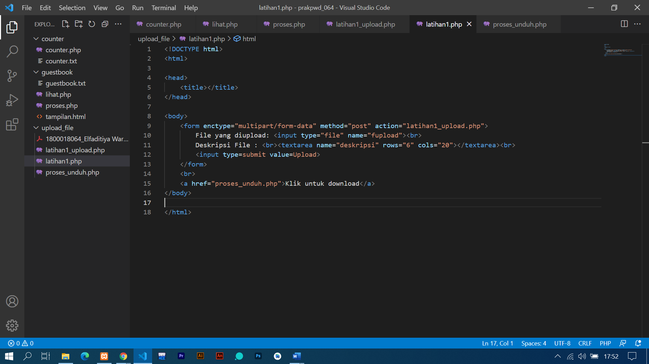

Tampilan Program

Source Code Upload latihan1_upload.php

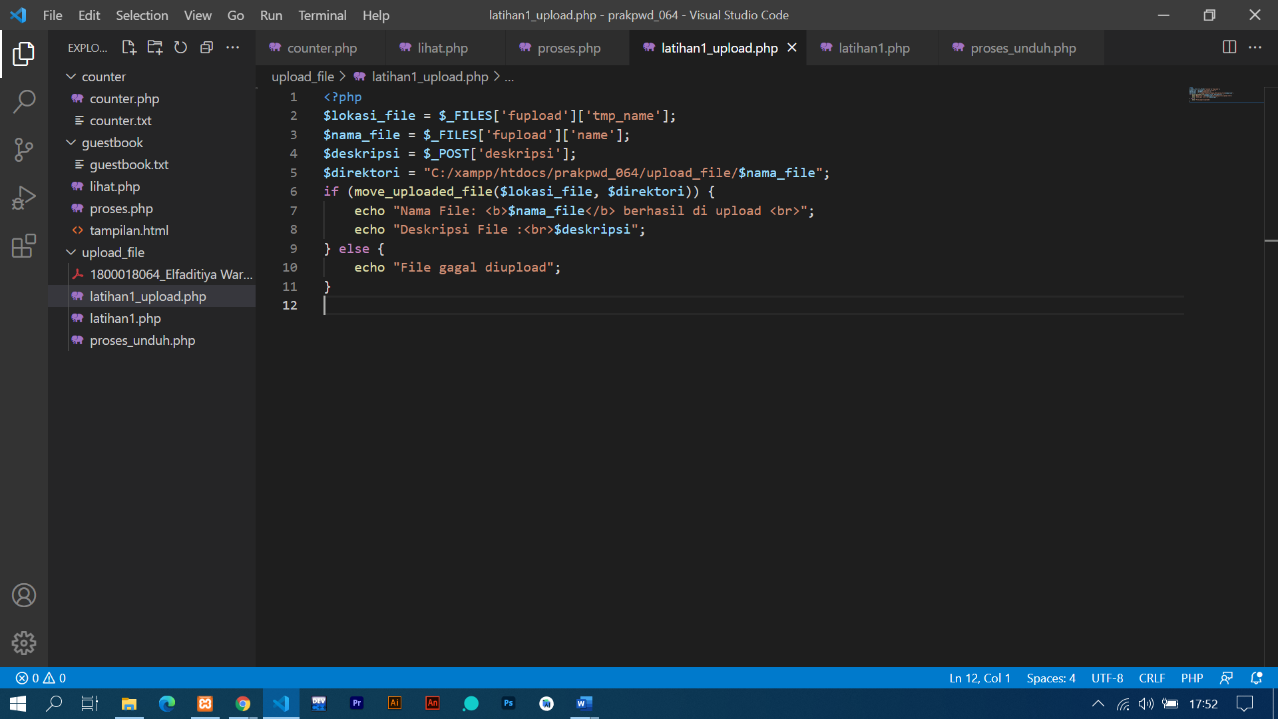

Tampilan Program

Source Code Upload prosesunduh.php

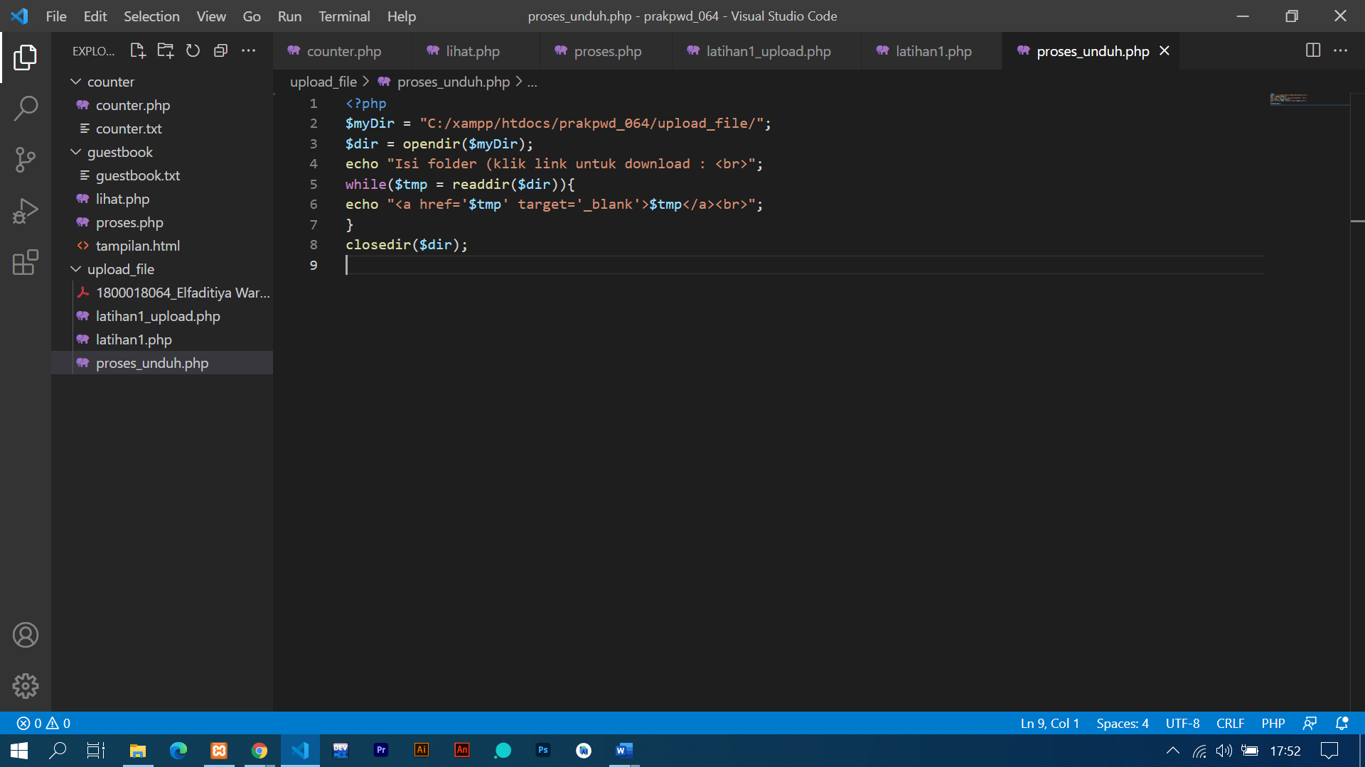

Tampilan Program